Abstract Title for MASIL 2019 Submission
Author 1, Author 2, and Author 3
1 Introduction
This document serves as a template for the abstract submission for a challenge and a research paper. We do not use an abstract here, because the submission consists only of 2 to 3 pages. Thus, the first section starts already with the introduction. Please, state in the introduction what approach you use for your software solution in case of a challenge contribution, or the motivation for your research and the state of the art in case of a research paper. Additionally, you should state in the introduction how your research is linked to the topic of the workshop (measurement and analyses of eye movements in natural environments).
2. Implementation
The second chapter in case of a challenge contribution is the implementation. Describe here the implementation details of your software, i.e. the applied object identification and tracking techniques, implementation details, object selection and tracking procedures. If you need subsections you can find examples in chapter 3. If you want to use equations, please use the formular editor and number the different equations in ascending order. For example:
We first calculate the z-vector of the head coordinate system in world coordinates
( $z_{head}^{world}$), with its origin in the head center and pointing towards the center of the field of view, by using the information of the three markers on the eye tracker helmet (i.e., left, right and front):

$z_{head}^{world}=H_{left}^{world}+ \frac{1}{2} (H_{right}^{world}- H_{left}^{world})$ (1)
where $H_{left}^{world}$ and $H_{right}^{world}$in Equation (1) are the positions of the right and left marker on the eye tracker helmet in the world coordinate system.

Author 1
XXX University, PO Box, 11111 city name + country e-mail: Author1 e-mail address
Author 2
XXX University, PO Box, 11111 city name + country e-mail: Author2 e-mail address
Author 3
XXX University, PO Box, 11111 city name + country e-mail: Author3 e-mail address
3 Experiment
The second chapter in case of a research contribution is the experiment. Describe here the purpose, experimental setup and experimental procedure of your study.
For example:

The present study investigates the influence of mental skill representations on the association of perception and action in a game sport scenario. We expect to find differences in the mental skill representations and in the visual gaze behaviour between experts and novices.

Participants: We tested 21 soccer experts (15 male and 6 females; 16 right-footed, 3 left-footed, 2 equally skilled with both feet; mean age = 25 years) and 21 novices (14 male and 7 females; 18 right-footed, 2 left-footed, 1 equally skilled with both feet; mean age = 23.71 years). The experts played from regional level up to the 1st division and had an average of 16.71 years of experience.

Stimulus material: Pictures of two different soccer players in sports wear per-forming the instep-kick were taken with a resolution of 4.1 mega pixel. The camera was fixed to a tripod for stability and to guarantee that all pictures were taken under the same perspective. During the photo session we ensured that the background did not contain distracting objects which could attract participants’ attention later on in the experiment.

Task and procedure: In the first part of the experiment, participants were tested in a perception task. The pictures of the soccer players were projected on a white wall using a projector set at 1400 ANSI-lumen brightness (see Figure 3). The projection had a size of 1:63 x 1:23 meter. The projector was placed on a 2.14 meter high shelf behind the participant in order to avoid that his or her head intersected with the projection field.
4 Results
This chapter serves to report the results of the challenge or research contribution.
For the challenge contribution describe your results on the automatic annotation on the gaze videos and report them for the single selected videos using the following table (please use a single table for each video):

Video  (name) | Object 1 |  | Object 2 |  | Object 3 |  | Object 4
 | numFix | fixDur | numFix | fixDur | numFix | fixDur | numFix | fixDur
Microwave1 | 5 | 7442 | 0 | 0 | 5 | 7210 | 1 | 290
Microwave2 | 7 | 5806 | 3 | 1222 | 8 | 4850 | 4 | 1000
Microwave3 | 7 | 7289 | 1 | 309 | 7 | 6720 | 1 | 370
Tab. 1: Results of the software solution for the average number of fixations (numFix) and fixation duration (fixDur in ms) in case of the single objects in the test videos for the microwave.

Video  (name) | Object 1 |  | Object 2 |  | Object 3 |  | Object 4
 | numFix | fixDur | numFix | fixDur | numFix | fixDur | numFix | fixDur
Supermarket1 | 7 | 4594 | 4 | 1647 | 8 | 3130 | 4 | 2070
Supermarket2 | 5 | 3063 | 4 | 2283 | 5 | 2110 | 3 | 1570
Supermarket3 | 3 | 3312 | 4 | 2183 | 6 | 2560 | 6 | 2520
Tab. 2: Results of the software solution for the average number of fixations (numFix) and fixation duration (fixDur in ms) in case of the single objects in the test videos for the supermarket.
Statistical results: In a research paper you can also use tables to summarize your results. If you state statistical analysis, you can do it in the following way: The results show that the amount of percentual attention distribution for novices is significantly higher than for experts (t(94) = 4:078; p = :001). On average, the scene area receiving attention in case of cue positions on the head or foot are 5.39 % and 7.03 % or 7.16 % and 7.81 % for experts and novices, respectively (see Figure 2). Additionally, we analysed the direction of the first saccade in case of reaction errors, i.e. participants pressed the wrong pedal, by a 2 (expertise) x 2 (kicking direction) x 3 (cue location) ANOVA.We found a significant main effect for expertise, F(1;36) = 4:934; p = :033). Furthermore, we found a significant interaction of the factors cue location x compatibility, F(1;36) = 4:105; p =.05.

Figures: If you want to use figures, you can do it in two ways: Either as one image or two images beside each other using a table.
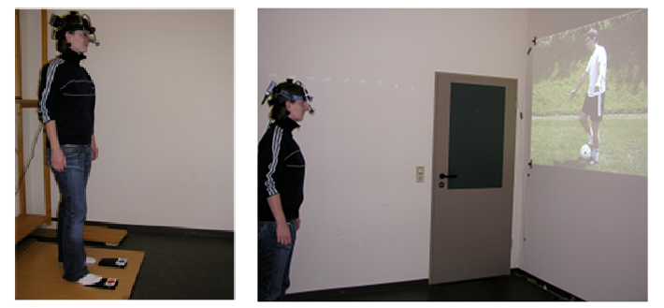
Fig 1: Experimental Setup

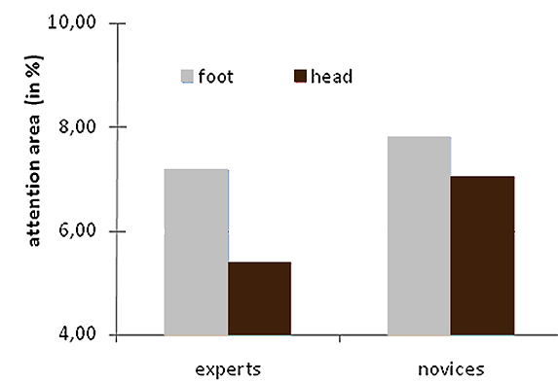  Fig. 2: Attention map areas for experts  and novices depending on cue location  (head v. ball). | 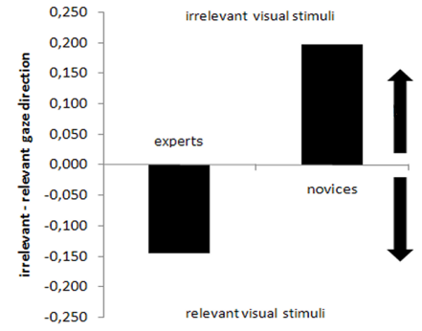  Fig. 3: Direction of the first saccade to relevant or irrelevant cue positions for experts and novices in case of reaction errors.
Citations of Figures, Tables and References:

Figure 1 depicts the experimental setup. Table 1 shows the annotation results for the microwave and Table 2 for the supermarket videos, respectively.
Thereby, examining differences in visual search strategies under conditions of game play has proofed to provide a window into the attentional processes underlying expertise decision making (Vickers, 2007; Williams & Ward, 2007). For a more thorough review of this literature see Williams, Davids, and Williams (1999); Williams et al., (2002).
5 Discussions and Further Work
Summarize your findings here and sketch possible future work.

ACKNOWLEDGMENTS: State here any acknowledgements. Otherwise, skip
this part.
References
1. Brass M, Bekkering H, Prinz W (2001). Movement observation affects movement execution in a simple response task. Acta Psychologica 106:3-22.
2. Helsen W, Powels JM (1992). A cognitive approach to visual search in sport. In: Brogan D, Gale A, Carr K. (ed), Visual Search, 2, (pp. 379-388), London: Taylor & Francis.
4. Knoblich G, Sebanz N (2008). Evolving intentions for social interaction: From entrainment to joint action. Philosophical Transactions of the Royal Society B. Biological Sciences 363: 2021-31.
5. Prinz W (1997). Perception and action planning. European Journal of Cognitive Psychology 9:129-154.
6. Schack T, Bar-Eli M (2007). Psychological factors of technical preparation. In: Blumenstein B, Lidor R, Tenenbaum G. (ed), Psychology of sport training - Perspectives on sport and exercise psychology, Volume 2, (pp. 62-103), Oxfort, UK: Meyer & Meyer.
7. Schack T, Hackfort D (2007). Action-theory approach to applied sport psychology. In: Tenen-baum G, Ecklund RC (ed.), Handbook of sport psychology (pp. 332-351). Hoboken, NJ: John Wiley & Son.
8. Schütz-Bosbach S, PrinzW (2007). Perceptual resonance: Action induced modulation of per-ception. TRENDS in Cognitive Science 11:349-355.
9. Vickers JN (2007). Perception, cognition and decision training: The quiet eye in action.Champaign (USA): Human Kinetics.
10. Williams AM, Davids K, Williams JG (1999). Visual perception and action in sport. London: E. & F.N. Spon.
11. Williams AM, Ward P, Knowles JM, Smeeton NJ (2002). Perceptual skill in a real-world task: Training, instruction and transfer in tennis. Journal of Experimental Psychology: Applied 8:259-270.
12. Zorzi M, Mapelli D, Rusconi E, Umilt` a C (2003). Automatic spatial coding of perceived gaze direction is revealed by the Simon effect. Psychonomic Bulletin & Review 10:423-429.
13. Croitoru A., Agouris P. , Stefanidis A. (2005). 3d trajectory matching by pose normalization. In GIS ’05: Proc. of the 13th annual ACM international workshop on Geographic information systems:153–162.
14. Fritsch J., Hofemann N., Sagerer G. (2004). Combining sensory and symbolic data for manipulative gesture recognition. In Proc. Int. Conf. on Pattern Recognition 3: 930–933.
15. TEX Users Group (TUG), http://www.tug.org.

